INSTITUTE OF TECHNOLOGY & SCIENCE
MOHAN NAGAR, GHAZIABAD-201002

NEWS TITLE: N.S.S Campaign for I.T.S
NEWSPAPER NAME: Dainik Jagran
DATED: 12 March, 2013
PAGE NO.: 18

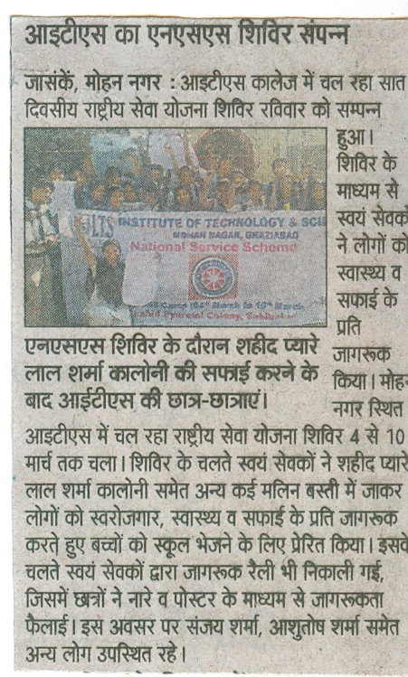

INSTITUTE OF TECHNOLOGY & SCIENCE
MOHAN NAGAR, GHAZIABAD-201002

NEWS TITLE: N.S.S Campaign for I.T.S
NEWSPAPER NAME: Navbharat Times
DATED: 12 March, 2013
PAGE NO.: 02

