INSTITUTE OF TECHNOLOGY & SCIENCE
MOHAN NAGAR, GHAZIABAD-201002

NEWS TITLE: Inter-College Cricket Tournament- 2013
NEWSPAPER NAME: Dainik Hint
DATED: 18 March, 2013
PAGE NO.: 03

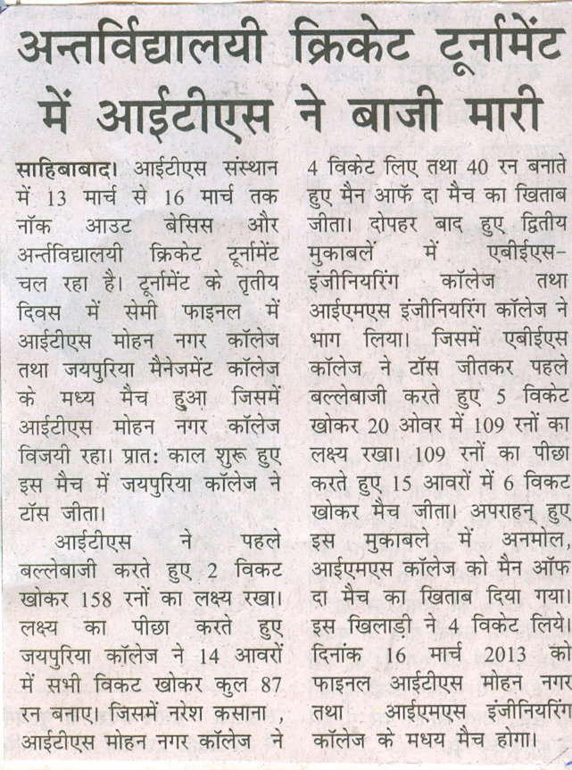

INSTITUTE OF TECHNOLOGY & SCIENCE
MOHAN NAGAR, GHAZIABAD-201002

NEWS TITLE: National Seminar on Information Technology at I.T.S
NEWSPAPER NAME: Dainik Yug Karvat
DATED: 18 March, 2013
PAGE NO.: 05

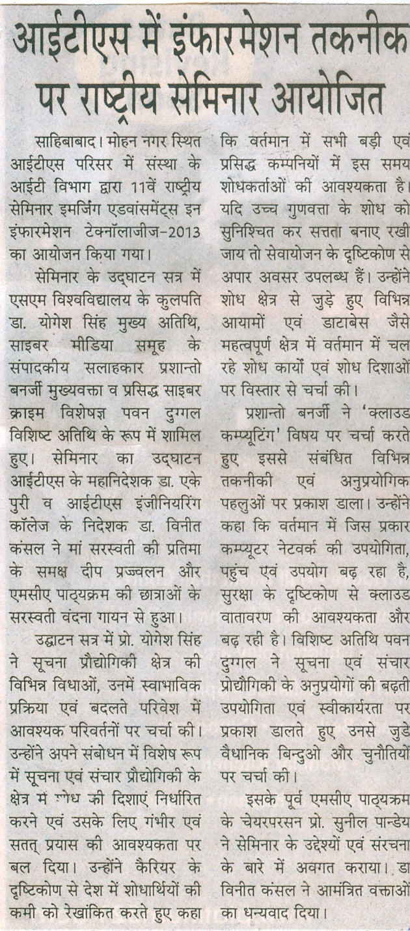

INSTITUTE OF TECHNOLOGY & SCIENCE
MOHAN NAGAR, GHAZIABAD-201002

NEWS TITLE: Inter-College Cricket Tournament- 2013
NEWSPAPER NAME: Dainik Yug Karvat
DATED: 18 March, 2013
PAGE NO.: 05

