INSTITUTE OF TECHNOLOGY & SCIENCE
MOHAN NAGAR, GHAZIABAD-201002

NEWS TITLE: AICTE Sponsored workshop ETRA 3GWC- 2013
NEWSPAPER NAME: Navbharat Times (THA)
DATED: 31 May, 2013
PAGE NO.: 03

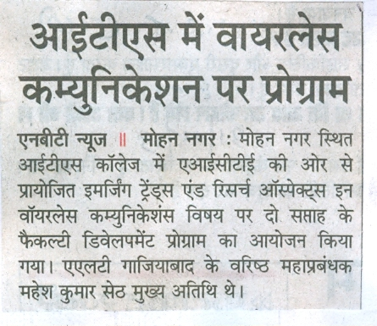

INSTITUTE OF TECHNOLOGY & SCIENCE
MOHAN NAGAR, GHAZIABAD-201002

NEWS TITLE: AICTE Sponsored workshop ETRA 3GWC- 2013
NEWSPAPER NAME: Amar Ujala
DATED: 30 May, 2013
PAGE NO.: 08

