INSTITUTE OF TECHNOLOGY & SCIENCE
MOHAN NAGAR, GHAZIABAD-201002

NEWS TITLE: Felicitation Program for Meritorious Student of 10th & 12th
NEWSPAPER NAME: Hindustan (Hindi)
DATED: 15 June, 2013
PAGE NO.: 21

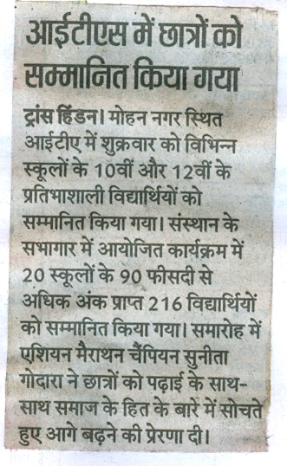

INSTITUTE OF TECHNOLOGY & SCIENCE
MOHAN NAGAR, GHAZIABAD-201002

NEWS TITLE: Felicitation Program for Meritorious Student of 10th & 12th
NEWSPAPER NAME: Navbharat Times (THA)
DATED: 15 June, 2013
PAGE NO.: 02



