INSTITUTE OF TECHNOLOGY AND SCIENCE
MOHAN NAGAR, GHAZIABAD-201007

NEWS TITLE : ITS STUDENT SELECTED FOR U.P. STATE SOFTBALL TEAM
NEWSPAPER : HINDUSTAN (HINDI)
DATED : 12-12-12
PAGE NO. : 21

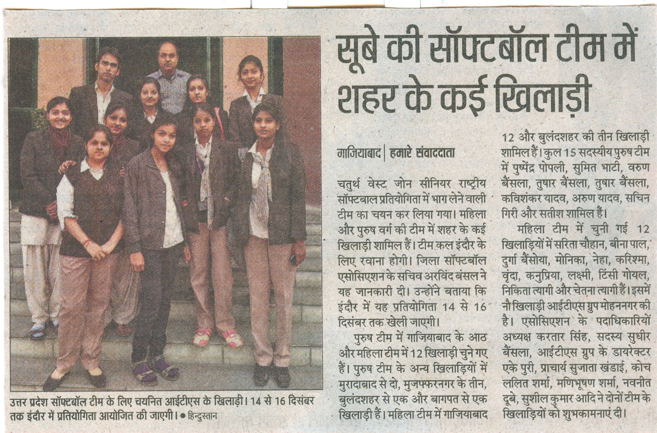

INSTITUTE OF TECHNOLOGY AND SCIENCE
MOHAN NAGAR, GHAZIABAD-201007

NEWS TITLE : ITS STUDENT SELECTED FOR U.P. STATE SOFTBALL TEAM
NEWSPAPER : NAVBHARAT TIMES
DATED : 12-12-12
PAGE NO. : 02

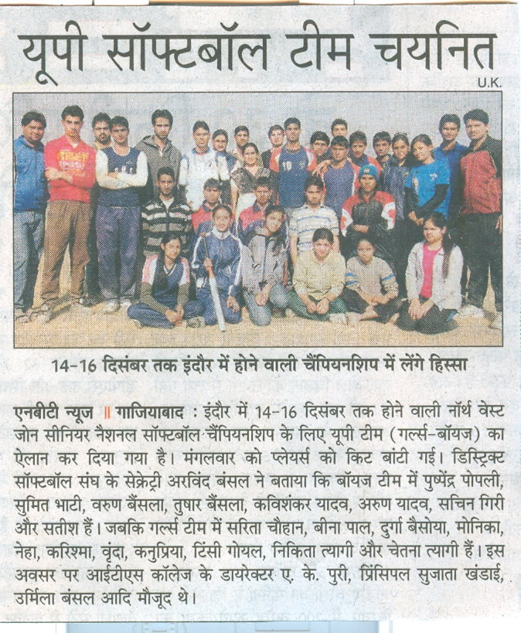

INSTITUTE OF TECHNOLOGY AND SCIENCE
MOHAN NAGAR, GHAZIABAD-201007

NEWS TITLE : ITS STUDENT SELECTED FOR U.P. STATE SOFTBALL TEAM
NEWSPAPER : DAINIK JAGRAN
DATED : 12-12-12
PAGE NO. : 20
